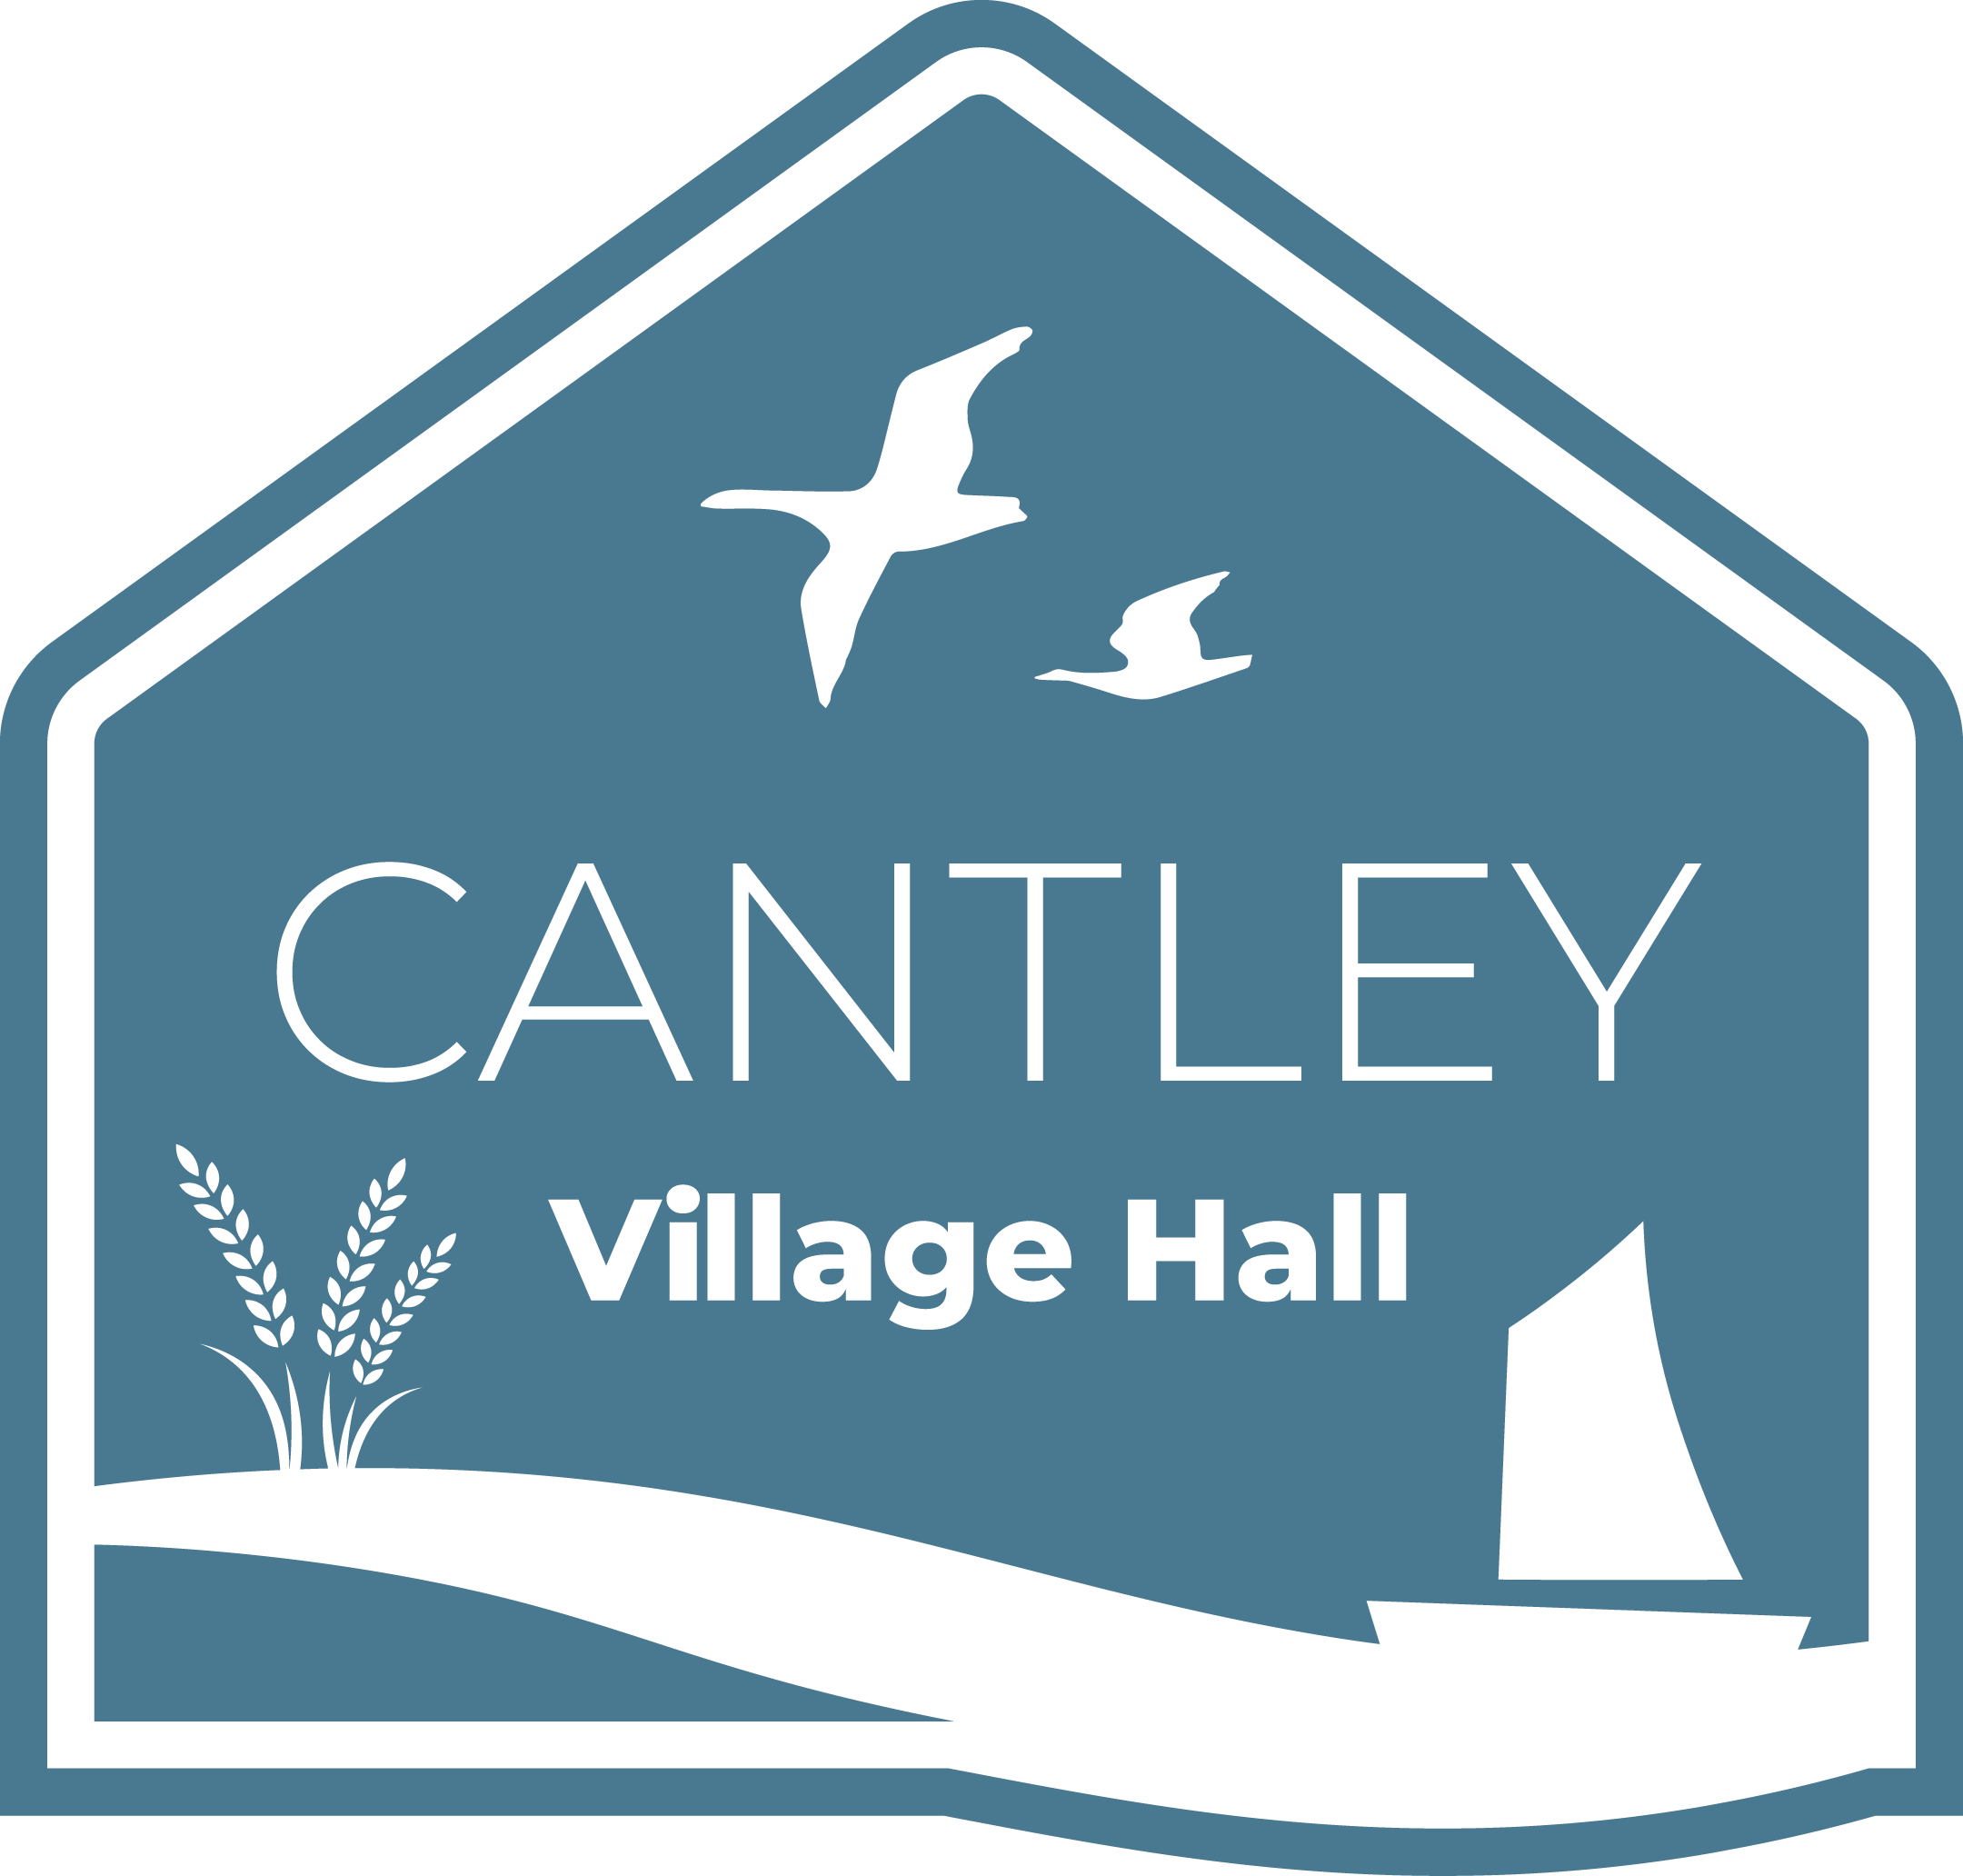
CANTLEY VILLAGE HALL BALANCE SHEET
FY 2024/25

31st March 2025

Assets
Current Assets
Description | Notes | Amount
Cash and Cash Equivalents | 1 | £200.00
Current Account Balance | 2 | £2,029.38
COIF Charities Investment Fund Balance | 3 | £13,265.78
Total Available Funds |  | £15,495.16

Accounts Receivable
Description | Notes | Amount
Grass cutting | 4 | £905.00
BDC Pride in Place drawdown grant | 5 | £25,000.00

Other Current Assets
Description | Notes | Amount
Gift Aid | 6 | £415.70
Paul Bassham Charity Grant | 7 | £2,000.00
Lord Belstead Charity Grant | 8 | £5,000.00

Total Current Assets: £33,320.70
Total Current & Available Assets: £48,815.86

Fixed Assets
Description | Notes | Amount
Buildings | 9 | £150,000.00
Furniture and Equipment | 10 | £15,200.00
Ground rent contract for Anglia Water mast | 11 | £7,000.00
Accumulated Depreciation (subtract) | 12 | (£2,000.00)

Total Fixed Assets: £170,200.00
Total Assets: £219,015.86

Liabilities
Current Liabilities
Description | Notes | Amount
Anglia Water | 13 | £2,000.00
BDC Business Rates | 13 | £2,760.00
Grass cutting | 13 | £1,120.00
Insurance (Contents and Buildings) | 13 | £1,673.61
Energy | 13 | £12,000.00
Cleaning | 13 | £2,400.00
Waste Collection & Duty of Care | 13 | £450.00
Accountants | 13 | £600.00
Phone & Broadband | 13 | £1,500.00
Marketing | 13 | £2,500.00
Repairs & Maintenance Contracts | 13 | £5,000.00
Bank Fees | 13 | £500.00
Volunteer & Staff Training | 13 | £450.00

Total Current Liabilities: £32,953.61
Total Liabilities: £32,953.61

Net Assets
Fund Type | Amount
Unrestricted Funds (General Fund) | £15,862.25
Restricted Funds (Project Funds) | £170,200.00

Total Net Assets: £186,062.25
Total Liabilities and Net Assets: £219,015.86

Summary Reconciliation
Total Assets | £219,015.86
Minus Total Liabilities | £32,953.61
Total Net Assets | £186,062.25
Balanced by
Unrestricted Funds: | £15,862.25
Plus, Restricted Funds | £170,200.00
Total Net Assets | £186,062.25

Notes on the Balance Sheet

- Retained as cash floats for events. Ability to take card payments introduced in Q3 24/25.
- Current Account at Barclays. The new process maintains £4,000 for cash flow; excess goes to investment.
- Investment account operated by CCLA Investment Management.
- Invoiced to the Parish Council May 25.
- BDC grant for Phase 1 invoices on a matched funding basis.
- Claimed March 25 for 23/24 crowdfunding.
- Received from Paul Bassham Charity.
- Received from Lord Belstead Charity.
- Valuation completed December 2022.
- Asset register completed February 25.
- Contract with Arqiva for 10-year ground rent.
- Depreciation per professional valuation.
- Estimated bills for FY25/26 based on previous trends and quotes.

